 | Sea-Floor Spreading
1 | The longest chain of mountains in the world is the mid-ocean ridge. In the mid-1900s, scientists mapped the mid-ocean ridge using sonar. Sonar is a device that bounces sound waves off underwater objects and then records the echoes of these sound waves. The mid-ocean ridge curves along the sea floor, extending into all of Earth's oceans. Most of the mountains in the mid-ocean ridge lie hidden under hundreds of meters of water. A steep-sided valley splits the top of the mid-ocean ridge for most of its length.
2 | Earth's ocean floors move like conveyor belts, carrying the continents along with them. This movement begins at the mid-ocean ridge. The ridge forms along a crack in the oceanic crust. At the mid-ocean ridge, molten material rises from the mantle and erupts. The molten material then spreads out, pushing older rock to both sides of the ridge. As the molten material cools, it forms a strip of solid rock in the center of the ridge. Then more molten material splits apart the strip of solid rock that formed before, pushing it aside. This process, called sea-floor spreading, continually adds new material to the ocean floor.
3 | Scientists have found strange rocks shaped like pillows in the central valley of the mid-ocean ridge. Such rocks can form only if molten material hardens quickly after erupting under water. The presence of these Ing. ore support came when scientists discovered that the rock that makes up the ocean floor lies in a pattern of magnetized "stripes." The pattern is the same on both sides of the ridge. These stripes hold a record of reversals in Earth's magnetic field. The final proof of sea-floor spreading came from rock samples obtained by drilling into the ocean floor. Scientists found that the farther from the ridge the rocks were taken, the older they were.
4 | The ocean floor does not just keep spreading. Instead, it sinks beneath deep underwater canyons called deep-ocean trenches. Where there are trenches, subduction takes place. Subduction is the process by which the ocean floor sinks beneath a deep-ocean trench and back into the mantle. At deep-ocean trenches, subduction allows part of the ocean floor to sink back into the mantle, over tens of millions of years.
5 | The processes of subduction and sea-floor spreading can change the size and shape of the oceans. Because of these processes, the ocean floor is renewed about every 200 million years. The Pacific Ocean is shrinking. Its many trenches are swallowing more ocean crust than the mid-ocean ridge is producing. The Atlantic Ocean is expanding. In most places, the oceanic crust of the Atlantic Ocean is attached to continental crust. As the Atlantic's floor spreads, the continents along its edges also move.

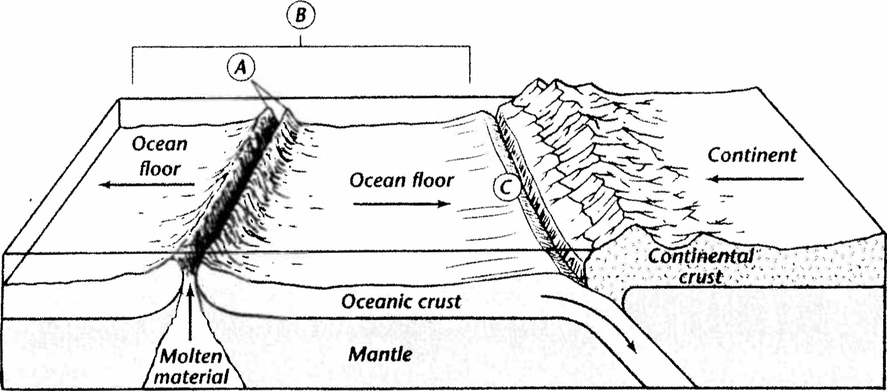

Using the text and the diagram answer the questions in the boxes to the right
- In the diagram, A is pointing at the mid-ocean ridge. Describe what happens at a mid-ocean ridge.

- In the diagram, B is showing you sea-floor spreading. Describe the process of sea-floor spreading.

- What happens to old oceanic crust at the mid-ocean ridge as new molten material rises form the mantle?

- What are three kinds of evidence scientists have found to support that the ocean floor is spreading from the mid-ocean ridge?
- In the diagram, C is showing you subduction. What is subduction and why does it occur?
- What device allowed scientists to map the ocean floor?
- What happens to the ocean floor at deep-ocean trenches? See C in the diagram.
- What is the geological process that continually adds new material to the ocean floor?

- What is the chain of mountains that extends into all the oceans on the Earth? See A in the diagram.
- The parts of Earth’s crust are continental and ocean crust. In your own words, explain why oceanic crust goes below continental crust at subduction zones.
(Hint: Remember DENSITY)

